Day-3
Session Info – UFTOne – 257 Testing
Parameterization using UFTOne
- Parameterization using GlobalSheet from Editor View
Browser("Register Account").Page("Register Account").WebEdit("firstname").set DataTable("firstname",dtGlobalSheet)
- Parameterization using GlobalSheet from Keyword view
- Parameterization using LocalSheet or Action Sheet from Editor View
Browser("Register Account").Page("Register Account").WebEdit("firstname").set DataTable("firstname",dtLocalSheet)
- Parameterization using LocalSheet from Keyword view
Setting from Solution :
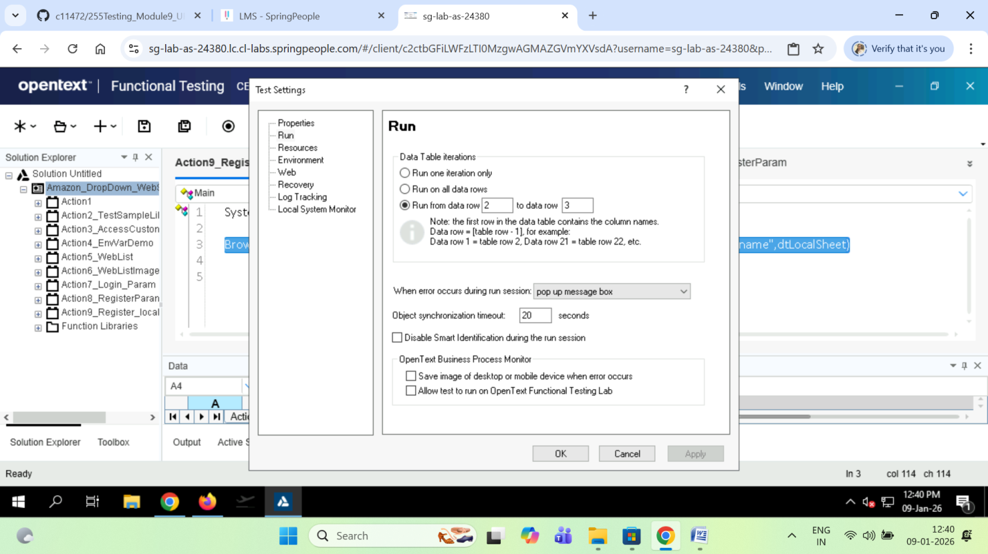

- Import data from Excel to Data Table
- Export data from Data Table to Excel

Scenario-1:
' To count totla number of books available as per search string from amazon.in home

SystemUtil.Run"https://www.amazon.in"
wait(2)
Browser("Online Shopping site in").Page("Online Shopping site in").WebEdit("Search Amazon.in").Set "java complete reference"
wait(2)
Browser("Online Shopping site in").Page("Online Shopping site in").WebButton("Go").Click
wait(2)
Set oDesc = Description.Create
oDesc("micclass").value="Image"

set p=Browser("Online Shopping site in").Page("Online Shopping site in").ChildObjects(oDesc)
msgbox("Total number of books present in the search res page" & p.Count)
wait(2)

For i = 0 To p.Count - 1
MsgBox p(i).GetROProperty("alt")
Next

Valid classes where the ChildObjects() will work

- WebEdit
- WebButton
- WebRadio
- WebList
- Link
- Image

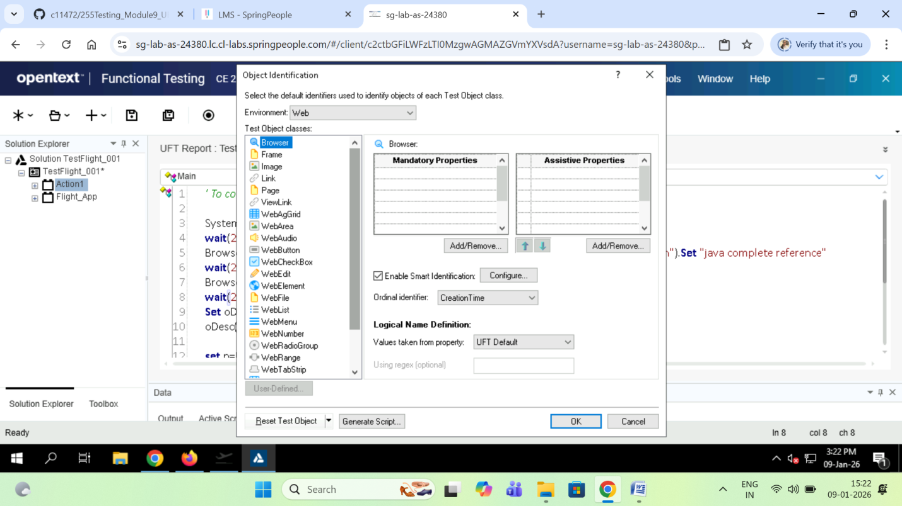

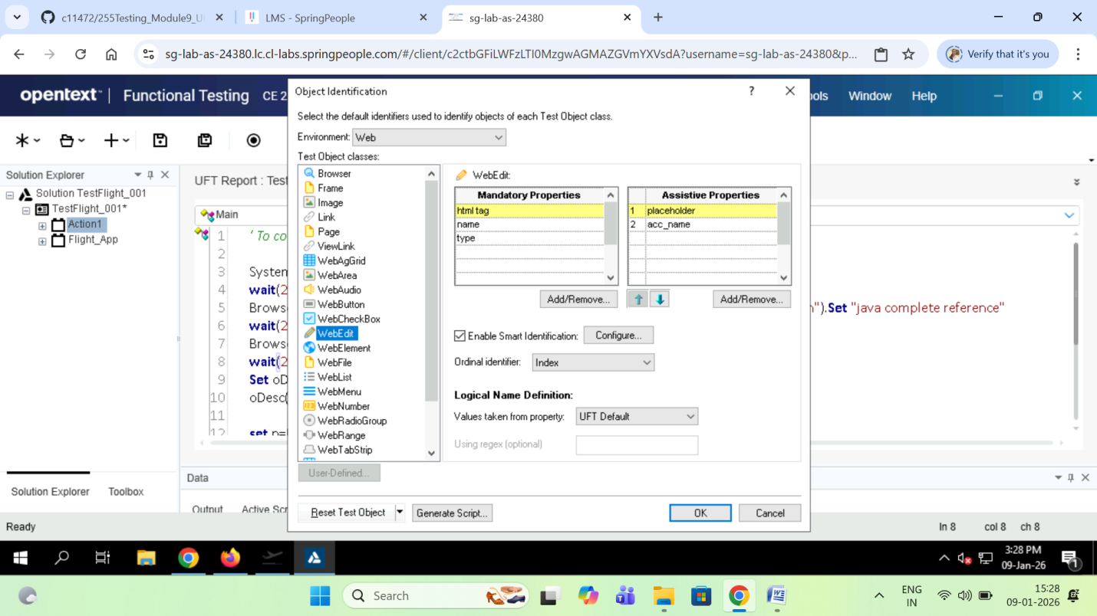

Sample Descriptive Programming :

Descriptive Programmig

Browser(nativeclass:='Chrome_WidgetWin_1",text:="Online Shopping site in India: Shop Online for Mobiles, Books, Watches, Shoes and More - Amazon.in - Google Chrome").
Page(title:="Online Shopping site in India: Shop Online for Mobiles, Books, Watches, Shoes and More - Amazon.in").WebEdit(name:="field-keywords",
html tag:="INPUT",
name:="field-keywords").set "test automation book"

